
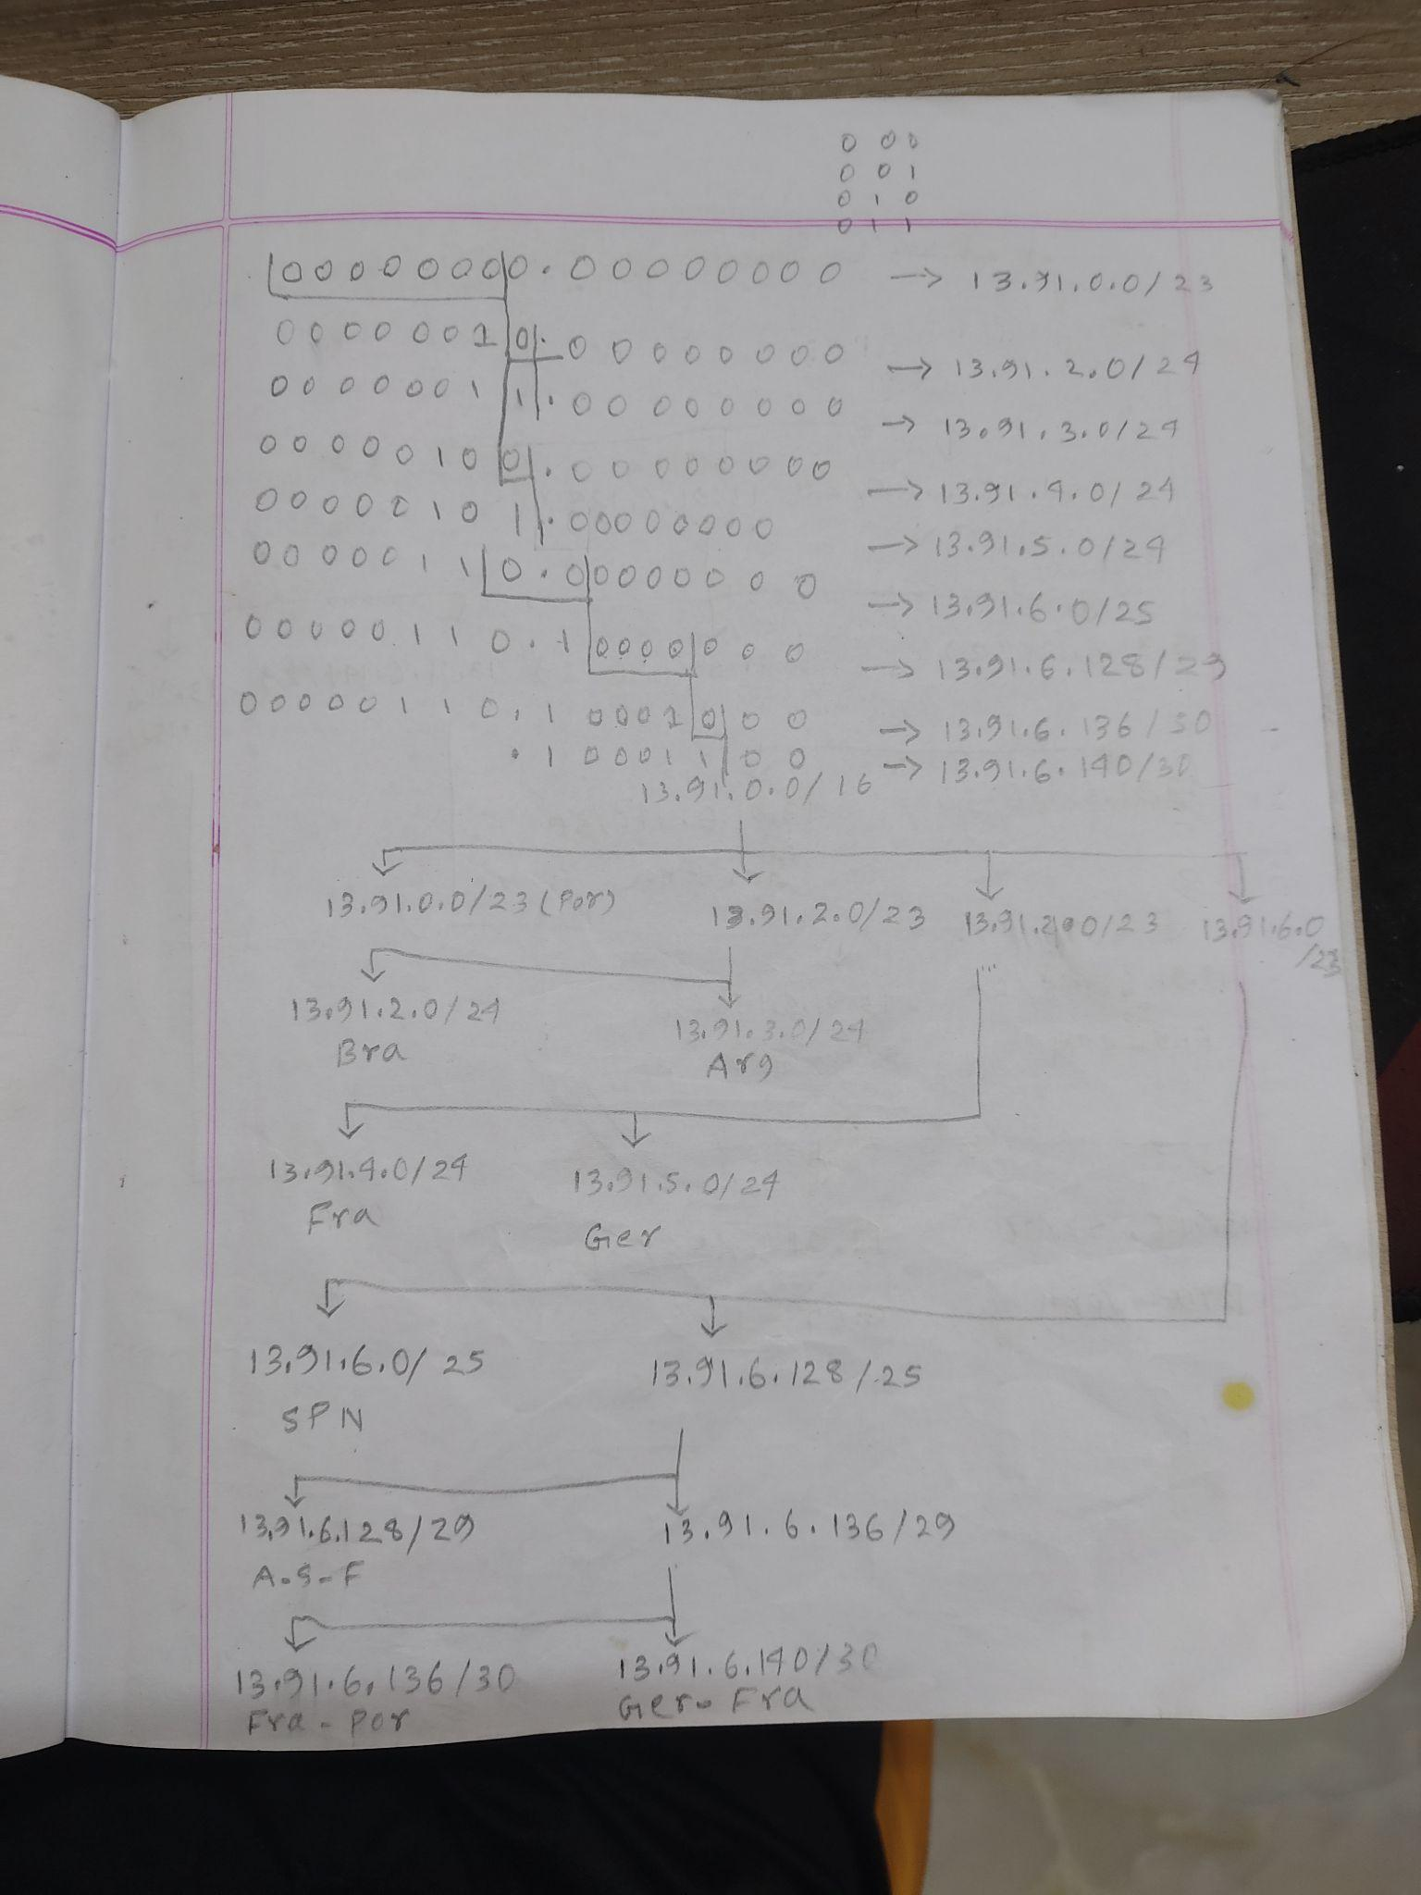
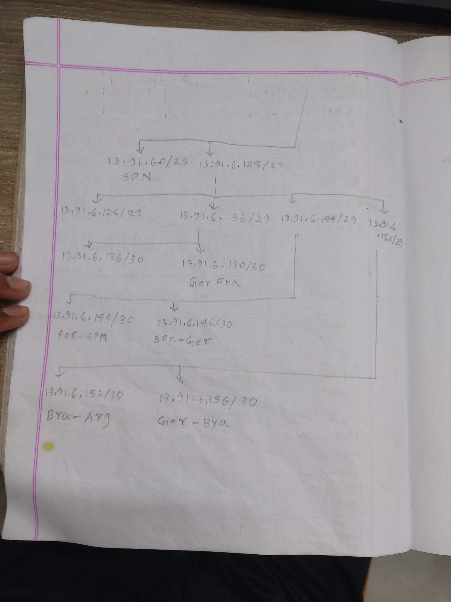

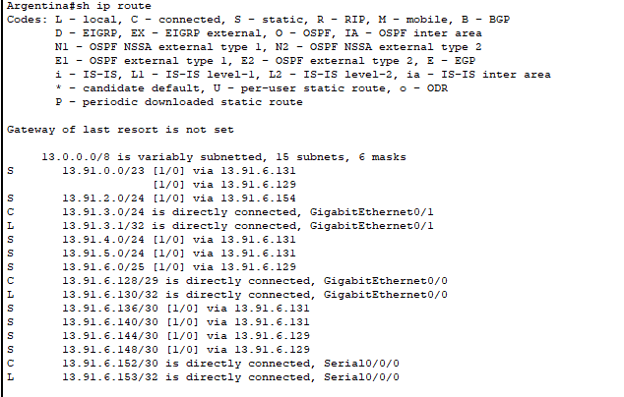
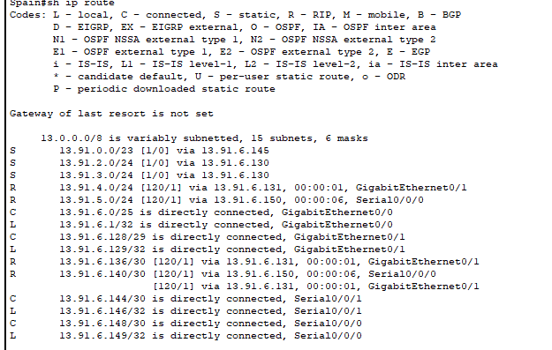
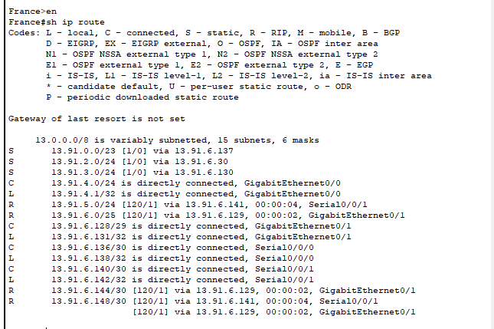
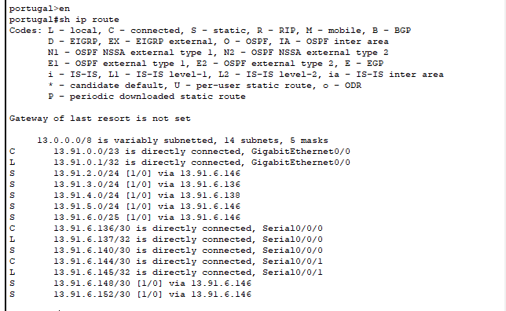
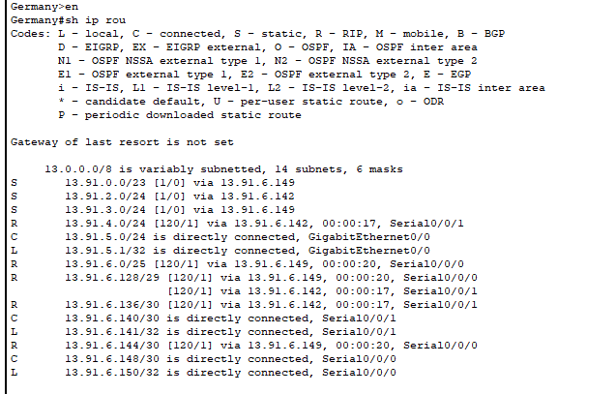
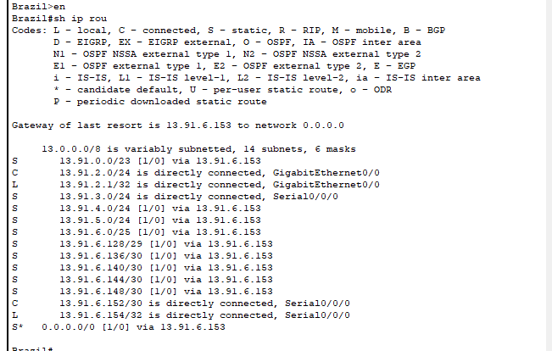

Commands:
France Router:
Int se0/0/0
En
Conf t
hostname France
Int se0/0/0
ip address 13.91.6.138 255.255.255.252
clock rate 128000
no sh
Int g0/0
Int g0/0
ip address 13.91.4.1 255.255.255.0
No sh
int se0/0/1
ip address 13.91.6.142 255.255.255.252
no sh
int g0/1
ip address 13.91.6.131 255.255.255.248
No sh

Email Server Fra:
Default gateway 13.91.4.1
Ipv4 13.91.4.2
France Router as DHCP:
ip dhcp excluded-address 13.91.4.0 13.91.4.10(excluded first 10 ip address for france)
ip dhcp excluded-address 13.91.6.0 13.91.6.10(excluded first 10 ip address for spain)
ip dhcp excluded-address 13.91.0.0 13.91.0.10(excluded first 10 ip address for portugal)
ip dhcp excluded-address 13.91.5.0 13.91.5.10(excluded first 10 ip address for germany)
ip dhcp pool spain
network 13.91.6.0 255.255.255.128
ip dhcp pool portugal
dns-server 13.91.3.5
default-router 13.91.0.1
network 13.91.0.0 255.255.254.0
ip dhcp pool germany
dns-server 13.91.3.5
default-router 13.91.5.1
network 13.91.5.0 255.255.255.0
ip helper-address 13.91.6.131(making spain a dhcp relay agent)
ip helper-address 13.91.6.138(making portugal a dhcp relay agent)
ip helper-address 13.91.6.142(making germany a dhcp relay agent)

ip dhcp pool Germany_pool
network 13.91.4.0 255.255.255.0
default-router 13.91.4.1
dns-server 13.91.3.5 (Central DNS server)
default-router 13.91.6.1(spain’s lan default gateway)

Dynamic routing protocol on France:
France(config)#router rip
France(config-router)#ver
France(config-router)#version 2
France(config-router)#no aut
France(config-router)#no auto-summary
France(config-router)#network 13.91.4.0
France(config-router)#network 13.91.6.128
France(config-router)#network 13.91.6.140
France(config-router)#network 13.91.6.136
passive-interface g0/0
Static Routing on France:
ip route 13.91.3.0 255.255.255.0 13.91.6.130
ip route 13.91.2.0 255.255.255.0 13.91.6.30

Alternate path to portugal:
ip route 13.91.0.0 255.255.254.0 g0/1 10

Portugal Router:
Int g0/0
En
Conf t
Int g0/0
ip add 13.91.0.1 255.255.254.0
no sh
Int se0/0/0
ip address 13.91.6.137 255.255.255.252
No sh

int se0/0/1
Int se0/0/1
ip address 13.91.6.145 255.255.255.252
clock rate 128000
No sh
Email Server Portugal:
Default gateway 13.91.0.1
Ipv4 13.91.0.2

Alternative path:
ip route 13.91.4.0 255.255.255.0 se0/0/1 10

Dynamic routing:
portugal(config)#router rip
portugal(config-router)#ver
portugal(config-router)#version 2
portugal(config-router)#no auto
portugal(config-router)#no auto-summary
portugal(config-router)#ne
portugal(config-router)#network 13.91.0.0
portugal(config-router)#ne
portugal(config-router)#network 13.91.6.136
portugal(config-router)#network 13.91.6.144
Passive interface g0/0
Dhcp relay:
portugal(config)#int g0/0
portugal(config-if)#ip he
portugal(config-if)#ip help
portugal(config-if)#ip helper-address 13.91.4.1
Static Routing on Portugal Router:
ip route 13.91.3.0 255.255.255.0 13.91.6.136
ip route 13.91.4.0 255.255.255.0 13.91.6.138
ip route 13.91.6.0 255.255.255.128 13.91.6.146
ip route 13.91.5.0 255.255.255.0 13.91.6.146
portugal(config)# ip route 13.91.2.0 255.255.255.0 13.91.6.146
portugal(config)#no ip route 13.91.2.0 255.255.255.0 13.91.6.146
portugal(config)# ip route 13.91.2.0 255.255.255.0 13.91.6.138
portugal(config)#no ip route 13.91.2.0 255.255.255.0 13.91.6.138
portugal(config)#ip route 13.91.2.0 255.255.255.0 13.91.6.146
portugal(config)#ip route 13.91.6.148 255.255.255.252 13.91.6.146
portugal(config)#ip route 13.91.6.140 255.255.255.252 se0/0/0
%Default route without gateway, if not a point-to-point interface, may impact performance
portugal(config)#ip route 13.91.6.152 255.255.255.252 13.91.6.146

Spain Router:
Int se0/0/1
int se0/0/1
ip address 13.91.6.146 255.255.255.252
No sh
Int se0/0/0
ip address 13.91.6.149 255.255.255.252
clock rate 128000
no sh
int g0/1
ip address 13.91.6.129 255.255.255.248
no sh
int g0/0
ip address 13.91.6.1 255.255.255.128
no sh
Mail server spn:
Default gateway 13.91.6.1
Ipv4 13.91.6.2
DHCP Relay:
int g0/0
ip helper-address 13.91.4.1(France router lan interface address)

Dynamic routing:
Spain(config)#router rip
Spain(config-router)#
Spain(config-router)#ver
Spain(config-router)#version 2
Spain(config-router)#no aut
Spain(config-router)#no auto-summary
Spain(config-router)#net
Spain(config-router)#network 13.91.6.0
Spain(config-router)#pas
Spain(config-router)#passive-interface g0/0
Spain(config-router)#network 13.91.6.128
Spain(config-router)#network 13.91.6.148
Spain(config-router)#network 13.91.6.144
Static routing:
ip route 13.91.3.0 255.255.255.0 g0/1
ip route 13.91.0.0 255.255.254.0 13.91.6.145
ip route 13.91.2.0 255.255.255.0 13.91.6.146

Germany Router:
int se0/0/0
ip address 13.91.6.150 255.255.255.252
No sh
int se0/0/1
ip address 13.91.6.141 255.255.255.252
clock rate 128000
no sh
int g0/0
ip address 13.91.5.1 255.255.255.0
no sh
Dynamic routing protocol:
Germany(config)#router rip
Germany(config-router)#version 2
Germany(config-router)#no auto su
Germany(config-router)#no auto summ
Germany(config-router)#no auto
Germany(config-router)#no auto-summary
Germany(config-router)#ne
Germany(config-router)#network 13.91.5.0
Germany(config-router)#net
Germany(config-router)#network 13.91.6.148
Germany(config-router)#network 13.91.6.140
Germany(config-router)#pas
Germany(config-router)#passive-interface g0/0
DHCP relay:
Germany(config)#int g0/0
Germany(config-if)#ip hel
Germany(config-if)#ip help
Germany(config-if)#ip helper-address 13.91.4.1
Static routing on germany:
ip route 13.91.3.0 255.255.255.0 13.91.6.149
ip route 13.91.0.0 255.255.254.0 13.91.6.149
ip route 13.91.2.0 255.255.255.0 13.91.6.142

Argentina Router:
int se0/0/0
ip address 13.91.6.153 255.255.255.252
no sh
int g0/0
ip address 13.91.6.130 255.255.255.248
no sh
int g0/1
ip address 13.91.3.1 255.255.255.0
no sh
Email server:
Default gateway 13.91.3.1
Ipv4 13.91.3.2
Web Server:
Default gateway 13.91.3.1
Ipv4 13.91.3.3
Printer:
Default gateway 13.91.3.1
Ipv4 13.91.3.4
Central DNS Server:
Default gateway 13.91.3.1
Ipv4 13.91.3.5
DHCP Server ARG:
Default gateway 13.91.3.1
Ipv4 13.91.3.6
Static routing:
ip route 13.91.6.0 255.255.255.128 g0/0
ip route 13.91.4.0 255.255.255.0 g0/0
ip route 13.91.2.0 255.255.255.0 se0/0/0
ip route 13.91.6.148 255.255.255.252 13.91.6.129
ip route 13.91.6.144 255.255.255.252 13.91.6.129
ip route 13.91.6.140 255.255.255.252 13.91.6.131
ip route 13.91.6.136 255.255.255.252 13.91.6.131
ip route 13.91.0.0 255.255.255.254 13.91.6.131
ip route 13.91.5.0 255.255.255.0 13.91.6.131

Brazil Router:
int se0/0/0
ip address 13.91.6.154 255.255.255.252
clock rate 128000
No sh
int g0/0
ip address 13.91.2.1 255.255.255.0
no sh

Static routing on brazil:
ip route 13.91.3.0 255.255.255.0 se0/0/0
p route 13.91.6.128 255.255.255.248 13.91.6.153
ip route 13.91.6.0 255.255.255.128 13.91.6.153
ip route 13.91.6.148 255.255.255.252 13.91.6.153
Brazil(config)#ip route 13.91.6.144 255.255.255.252 13.91.6.153
Brazil(config)#ip route 13.91.6.140 255.255.255.252 13.91.6.153
Brazil(config)#ip route 13.91.6.136 255.255.255.252 13.91.6.153
Brazil(config)#ip route 13.91.4.0 255.255.255.0 13.91.6.153
Brazil(config)#ip route 13.91.0.0 255.255.254.0 13.91.6.153
Brazil(config)#ip route 13.91.5.0 255.255.255.0 13.91.6.153
default route:
ip route 0.0.0.0 0.0.0.0 13.91.6.153

